Zero to $1000/day w/ branded dropshipping in 2026

(r3tard proof)

[Mark Builds Brands]
run more ads.

This is a doc I will be consistently updating as time goes on.

SECTION 1: READ THIS FIRST mfers
Disclaimer #1: What you're about to read took me 7+ years and tens of millions in ad spend to figure out. This is extremely valuable. Take advantage of it while you can.
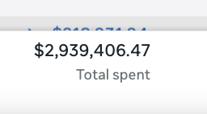
This is from 1 ad account ⬇️

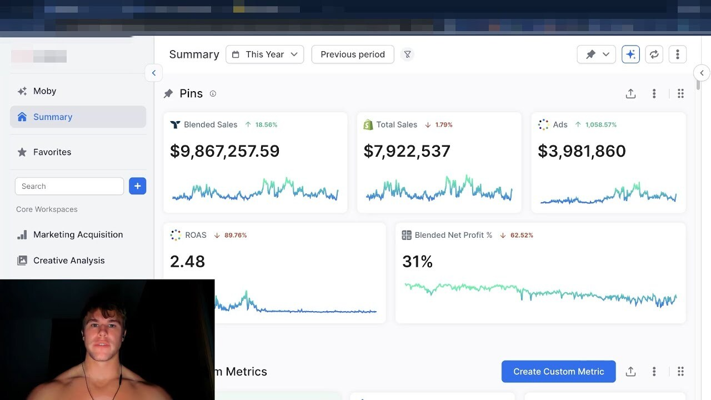
2025 results from 1 of my brands. ⬇️

Disclaimer #2: This guide is for people who are serious about building a real business online. If you're looking for a get-rich-overnight hack, close this document right now. Seriously. I don't want you here. kunt.

Still reading? Good.
The game has changed. It's 2026, and what worked in 2018, 2020, and even 2023 is dead or dying.
The people who are winning right now are doing things completely differently. And in this guide, I'm going to show you exactly what I would do if I were starting from absolute zero today.
The goal? $1K per day in revenue.
Why $1K/day? Because at 30% margins, that's roughly $10K per month in profit. That's the milestone that changes everything. Ask anyone who's made serious money in their life they'll tell you that first $10K/month felt better than $100K/month. It's the one you remember. It's the one that proves this shit actually works.
And I'm going to show you exactly how to get there with three things. Not thirty. Not three hundred. Three.
But first, if you don’t know who i am and why you should even listen to me… here’s what this next section. (if you are an OG MBB viewer just skip to section 3)

SECTION 2: MY STORY (speedrun)
I started this journey in 2018. I was 18 years old, going into college, skinny, and I had absolutely no idea what I was doing.
College was never really my thing. I went because my mom wanted me to. I did enough to get by and poured every other ounce of energy into two things:
- the gym (obviously traps aren't gonna grow overnight bro)
- building my biz.
Here's what nobody tells you about the beginning: it fucking sucks.
I lost money for 9 straight months. Nine fucking months.
I tested over 50 products. Nothing worked. Every single one was a failure. I'd spend money on ads, watch it drain, and start over. Again and again and again.
Yes 50 products, 50 different stores, and 100s of ads tested. About $9000 down the drain…
I was hungry. not "hustle culture" hungry, like actually didn't have money for food hungry. Like about to get evicted hungry. Wanna talk about motivation? Motivation was the last goddamn thing on my mind. I wasn't motivated. I was desperate.
But I kept going. Not because I'm special or built different or any of that Instagram bullshit. I kept going because I literally had no other option.
Fast forward a week or so on my 50th PRODUCT… everything finally aligned.
I ended up making enough from that store to cover my $9000 loss plus some.
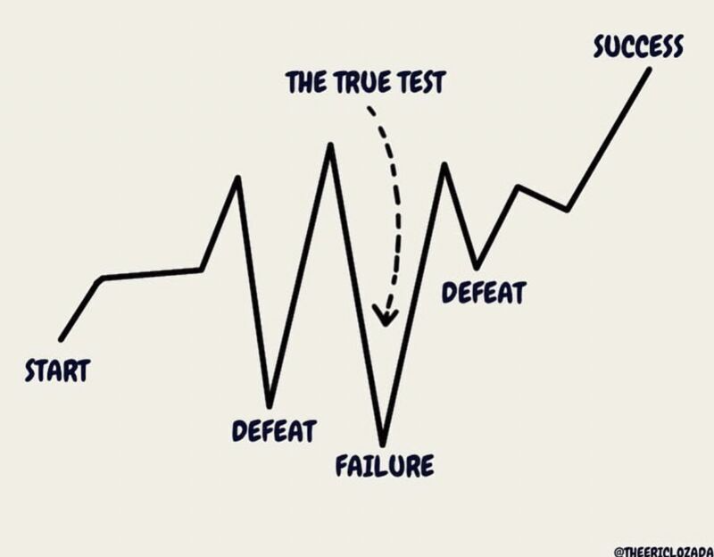
Today I've spent tens of millions on ads. I've built and scaled multiple ecommerce brands. I've mentored hundreds of people through Brand Builders Academy.
And I still work 12-16 hour days because I genuinely love this shit.
blah blah blah
Ok, you get the point… obviously there's a lot more to that story, but you didn't come here about me… this is about you.
But here's the truth: none of that would have happened if I hadn't gotten the fundamentals right first.
And that's exactly what this guide is about…
The fundamentals.
If I had to start over tomorrow no money, no connections, no experience this is the exact blueprint I would follow. Step by step.
Let's get into it.

SECTION 3: MINDSET. GET YOUR HEAD RIGHT FIRST
I know. I know.
"Mark, I thought you were going to teach me how to make money. What the fuck is this mindset shit?"
Good question. If that's your reaction if you genuinely think that getting your mind right is a waste of time then close this document. I'm serious. Get the fuck out of here.
Because here's the reality: if you don't get this right, everything else in this guide is useless.
You think you're getting into dropshipping. You're not. You're getting into entrepreneurship. And entrepreneurship is difficult. It's emotional. It's messy. And if your mind isn't built for it, you will quit. Guaranteed.
I'm not going to spend 10 pages on this. But there are four rules that will determine whether you make it or not.

RULE #1: DETACH LIKE YOUR LIFE DEPENDS ON IT
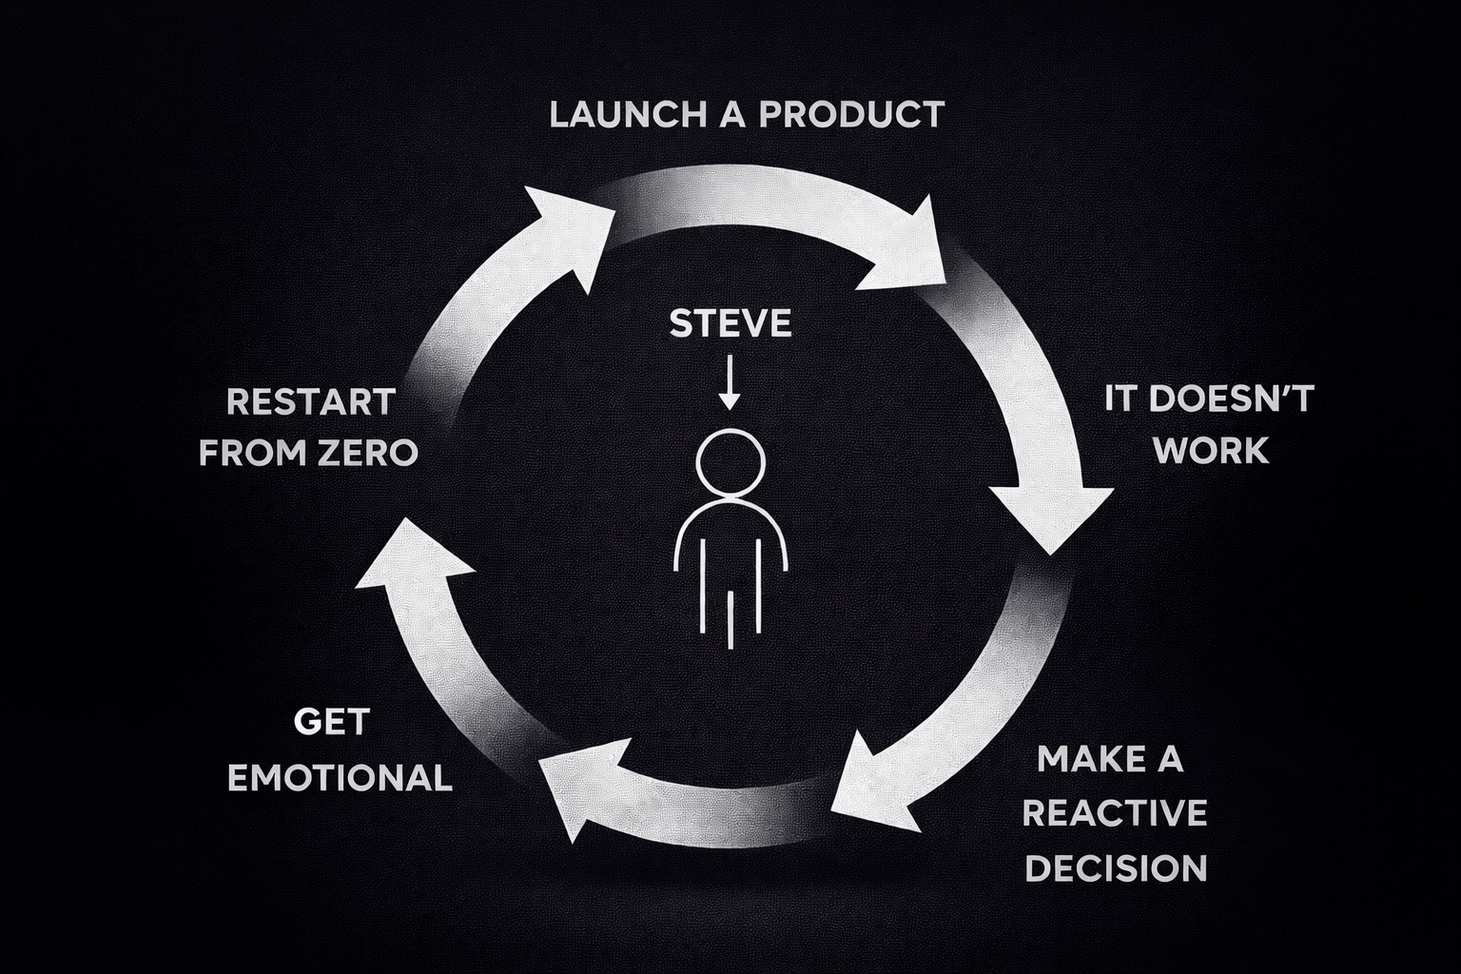
Here's what happens to most people: they launch a product, it doesn't work, they get emotional, they make a reactive decision, and they restart from zero. Over and over and over.
Don’t be Steve (ifykyk)
The problem isn't the product. The problem isn't the ads. The problem is that your emotions are running your business.
You need to detach and analyze your business like an investor, not an entrepreneur. Entrepreneurs are reactive. Investors are proactive. They look at data. They make decisions based on numbers, not feelings.
When your ads aren't working, you don't panic. You read the data. When a product fails, you don't cry about it. You learn from it and move on.
Detach. Analyze. Decide. Move.
That's it. That's rule number one.

RULE #2: YOU'RE R3tarted. ADMIT IT.
I'm not being mean. I'm being honest.
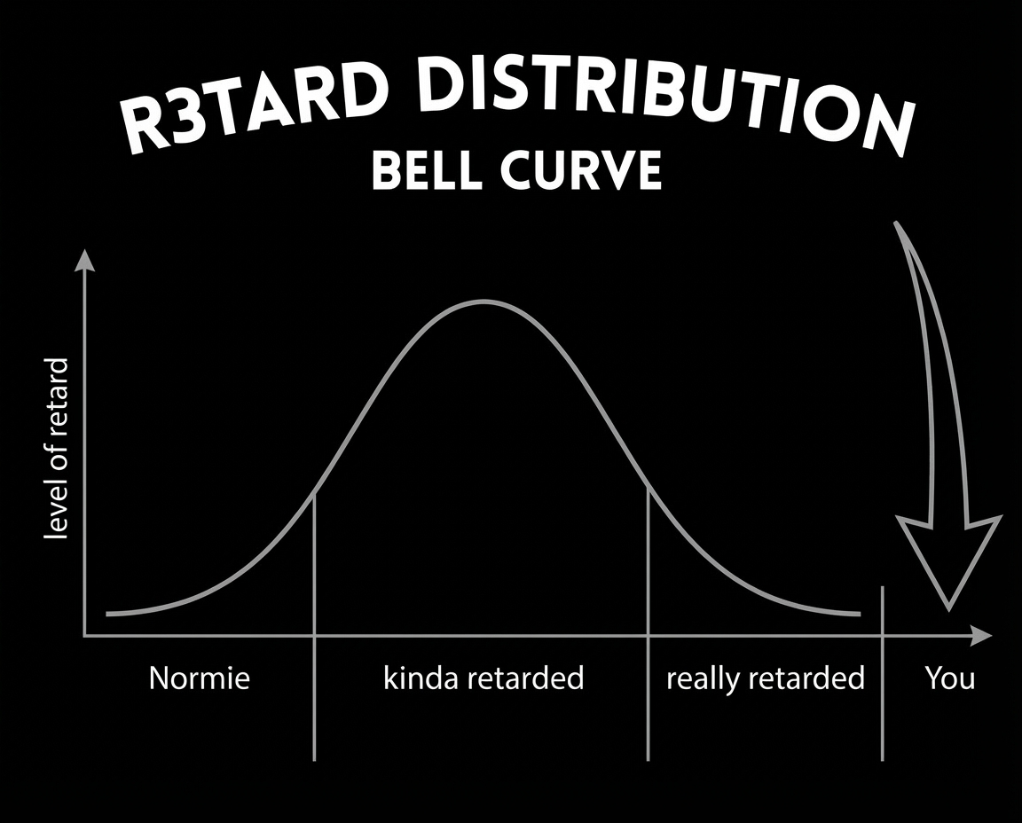
You don't know everything. Neither do I. We're a bunch of idiots at the end of the day. There are many, many people substantially smarter than you. If this were a bell curve, you didn't even make it onto the curve dude.
And that's OKAY as long as you admit it and seek help.
There are two ways to get better at anything:
- Learn from your own mistakes
- Learn from the mistakes of others
I don't care what you think about course creators or gurus or the "info space." That whole narrative gave a terrible reputation to what is really just learning. And learning from people who have fucked up more than you is the fastest shortcut that exists.
Buy a consulting call. Join a mentorship. Watch free YouTube content. Read books. I don't care how you do it. What matters is that you're getting high-quality information from people who've been in the trenches.
How you learn is less important than that you learn.

RULE #3: KEEP A LEARNING JOURNAL
Not a feelings journal. A learning journal.
Write down everything you learn. Every YouTube video, every consulting call, every test result, every insight. I have journals from my first two or three years that are filled with pages and pages of notes from $47 courses, random YouTube videos, and conversations with other entrepreneurs.
You can't remember everything. And if you're not keeping track of what you're learning, you don't really care about getting better that much.
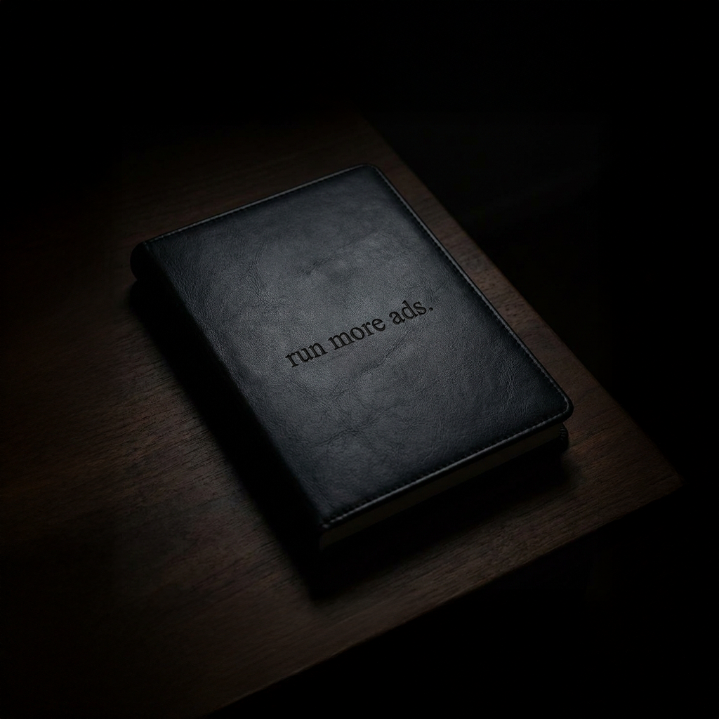
This is incredibly underrated. Do it.

RULE #4: MONEY LOVES SPEED (my favorite rule)
This is the one that separates the winners from everyone else.
I've had hundreds of students go through BBA. The ones who become successful the fastest all share one single trait: they stop trying to study and prepare perpetually, and they just start doing.
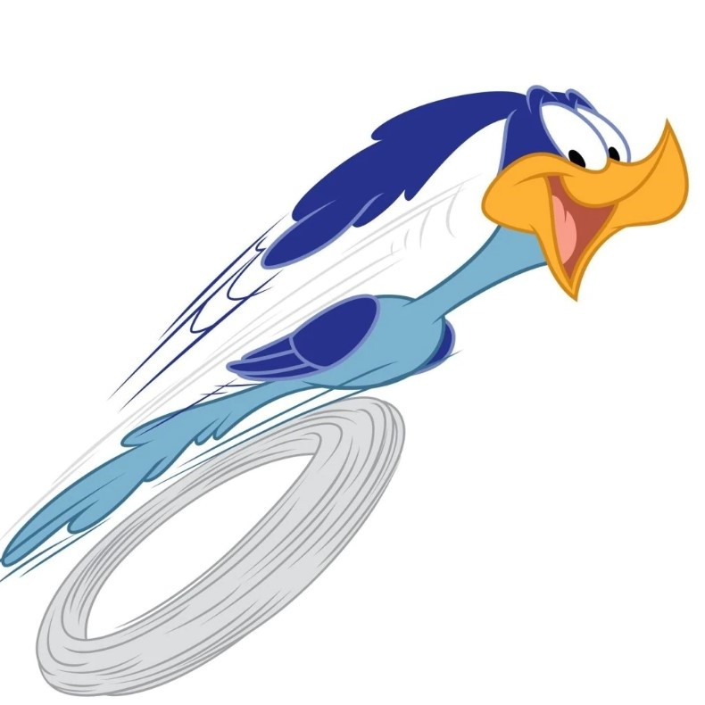
You don't know shit. Preparation is not going to serve you that much. You need to start getting your hands dirty. Start testing products. Start testing ads. Start testing funnels. You will learn way, way, way more by doing that for one week than you will by studying for one month.

They say talk is cheap. Well… action is expensive because nobody wants to do it. But it's the most valuable thing you can actually do.
Stop preparing. Start doing. Money loves speed.

SECTION 4: THE FORMULA… THREE THINGS, THAT'S IT
All right, let's talk about actually making money.
The formula for getting to $1K/day is simple. Notice I didn't say easy… I said simple. There's a difference.
Ok here’s what you need to succeed:
- PRODUCT
- FUNNEL
- ADS
That's the entire formula. Three things.
And here's the part that's going to blow your mind: you don't need to be very good at any of them.
Shocker right?
The thing that really wins in dropshipping is simplicity. I know many, many people making serious money who are not the sharpest tools in the shed I'll put it that way. But they have a decent product, a very simple funnel, and a simple ads process. And that's it.
There’s no need to overcomplicate it… just stick to the basics.
Source: Trust me bro.

THE MARKETING GAME
Here's something important: at the beginning, ecom is a marketing game. Let's just call it what it is.
I have a friend who has never done ecommerce before. He's a marketer he understands ads and funnels. He asked me for some advice. In one week, he tested three products. 100% win rate. Every single one was profitable. Every single one was promising.
How? Because when you're trying to get from $0 to $1K/day, marketing is everything. The product matters, but not as much as you think. What matters way more is your ability to get a click, land that click on a page that converts, and do it profitably.
Now, if you want to get from $1K/day to $10K/day to $100K/day yes, the game changes. But right now? Focus on the marketing.
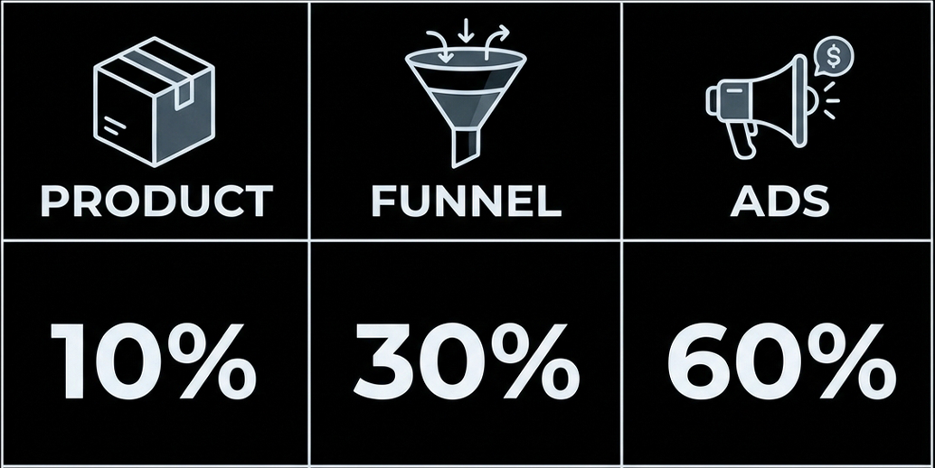
And foreshadowing here… but it very heavily skews toward the funnel and the ads.
So let's break down all three starting with the one that matters least.

SECTION 5: The PRODUCT
As I said: simplicity is king. When I'm looking for products to test, I'm not looking for something nobody's ever seen. I'm looking for the exact opposite.

PROVEN DEMAND IS EVERYTHING
I don't sell anything that isn't already proven. Period.
The way I validate this is simple: I want to see at least one competitor doing at least $300K per month selling something similar. That's it. One competitor. Doing real volume.
"But Mark, how do I know how much someone else is doing?"
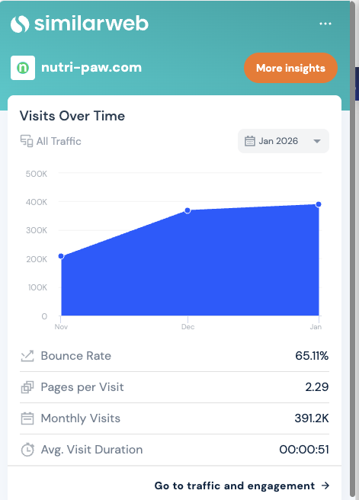
Great question. Here are a few methods:
Method 1: SimilarWeb
Go to similarweb.com, get the Chrome extension, and look at their traffic volume.You can generally tell how well someone is doing based purely on traffic. Ideally looking for 300k+ visits per month and trending up.
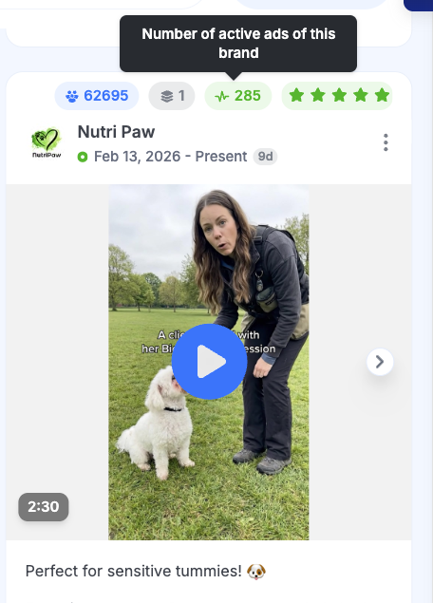
Method 2: GetHookd (Ad Spy)
Look for competitors that have 100+ active ads in their Meta ad library. If someone is running that many ads, they're spending serious money which means they're making serious money.
Method 3: Google Keyword Tracking
Go to ads.google.com, open a free account, and search for keywords related to your product. You want to see at least 30,000 monthly searches for the main term.
Method 4: Helium 10 (Amazon)
Check Amazon sales volume for similar products to estimate market demand.
The method is actually less important than the principle: sell something that's already proven to work.

THE MARGIN RULES
Good margins are not optional. They're the difference between a business and a hobby that loses money.
Two rules. Both must be met.
Rule #1: At least $30 gross margin
Take your selling price, subtract your product cost including shipping. That number needs to be at least $30.
Rule #2: At least 3x your COGS (including shipping)
If your product costs $40 to manufacture and ship, you need to sell it for at least $120.
Example:
Selling price: $100
COGS (product + shipping): $40
Gross margin: $60
But $100 is only 2.5x of $40
If you can sell that same product for $120:
Gross margin: $80
3x COGS: $120 = 3x of $40
Both rules met. Now you have a product worth testing.

PURPLE OCEAN THEORY
This is one of the most important concepts in this entire guide.
You've probably heard of Blue Ocean and Red Ocean theory. Quick refresher:
Red Ocean = Extremely saturated market. Competitors everywhere. Margins get compressed down to nothing. Think selling a generic carnivore supplement with zero differentiation. You and 500 other people all had the same "brilliant" idea.
Blue Ocean = Zero competition. Sounds great, right? Except zero competition usually means zero demand. You invented a product nobody wants. Congratulations.
Both of these suck.
Purple Ocean is where you want to be. You enter a proven, red-ish market, but you carve out a hyper-specific demographic within it.
Example 1: Primal Queen
The carnivore supplement market is red. But Primal Queen sells carnivore supplements specifically for women who are postpartum or perimenopausal. Hyper-specific. Purple ocean.
Example 2: Nootropics for Entrepreneurs
I personally bought nootropics back in 2018, not because they were the best ones on Amazon, but because they were marketed as nootropics specifically for entrepreneurs. Purple ocean. That company exited.
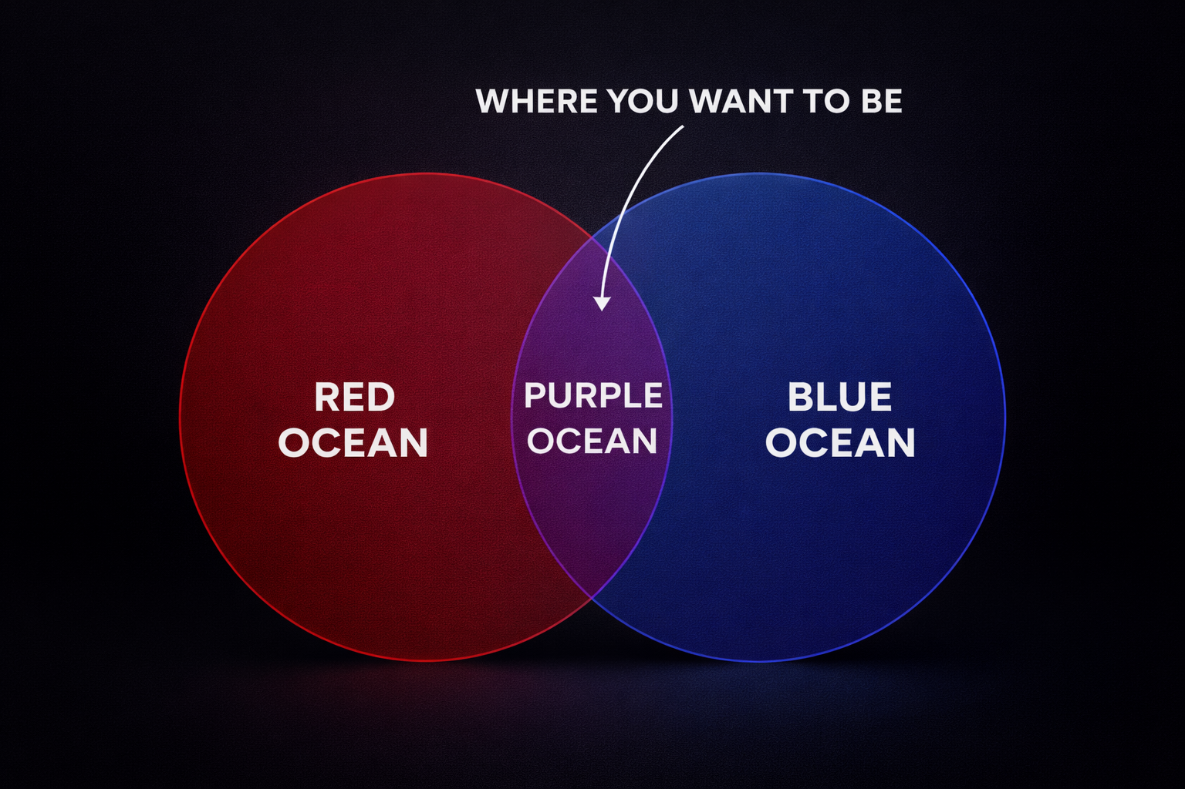
If you try to sell to everybody, you're really selling to nobody.

Side Note: DROPSHIPPING IS NOT A BUSINESS MODEL
I need to say this clearly: dropshipping is a fulfillment model, not a business model.
It's literally just shipping a product from your supplier to your customer without a warehouse in the middle. Walmart does it. Apple does it. Home Depot does it. It's just a way to fulfill orders.
You should be using dropshipping to validate that you can actually sell a product. Once it's validated, you build a real brand around it.
There's a reason why most dropshippers' income looks like an EKG up, down, up, down. It's because they're not building anything sustainable. They find a product, milk it, it dies, and they start over.
This guide is called branded dropshipping for a reason. Build a brand.
Ok… it’s out of my system… for now… let’s move on.

SECTION 6: FUNNEL SIMPLICITY SCALES
A funnel is just taking somebody who clicks on your ad and turning them into a buyer. That's it. Don't overcomplicate it.

START ON SHOPIFY. USE SHRINE. DONE.
I've built literally hundreds of funnels. Maybe over a thousand. I run stuff on Funnelish, Checkout Champ, ClickFunnels, custom-built pages you name it.
And I'm telling you: start on Shopify with the Shrine theme.
It's tried and true. It works. My friend who had never done ecom before? He used Shrine on every single product he tested. Went 3 for 3 in one week.
If you have been watching my videos for awhile you know I talk a lot about pre-landers, advertorials, and advanced funnel architecture. And I love that stuff long-term, it's phenomenal. But if you're just getting off the ground? Simplicity scales. You don't need a pre-lander yet. You don't need a VSL. You don't need a quiz funnel.
You need a clean Shopify store on Shrine that converts. Period.

THE FOUNDATIONAL DOCS PROCESS
This is the single most important process in this entire guide that nobody talks about.
Before you write a single word of copy, before you create a single image, before you do ANYTHING you need to run the Foundational Docs process.
This is an AI-powered market research system where you use Claude (I recommend Sonnet or Opus doesn't matter much) to build deep research documents on:
- Who you're selling to
- Why they're buying
- What emotional buttons you can push
- How they talk about their problems
- What objections they have
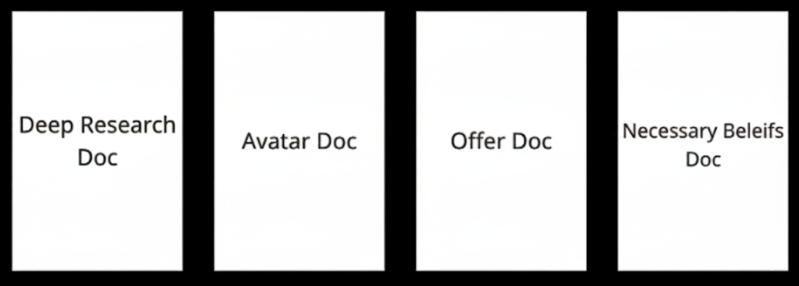
These are the 4 docs you will be making with AI
You save all of these as PDFs in a folder. Then you use them to write ALL of your copy, create ALL of your images, and inform ALL of your ads.
If you do this, everything downstream becomes easier. If you skip this, everything downstream becomes harder.
Spoonfed guide on how to create these here

AI BUILDS YOUR ENTIRE STORE
It's 2026. AI is not going anywhere. And if you're not using it, you're working 10x harder than you need to be.
Here's exactly what you need:
For Copy: Claude
Claude Sonnet or Opus use the foundational docs you built to feed it context, and it will write product descriptions, headlines, landing page copy, everything. You don't need to be a copywriter.
For Images: NanaBanana Pro
One tool. That's all you need. Learn to prompt. You can create product images, lifestyle images, and anything else you need. If you can't prompt well, have the AI write your prompts for you. It's not that hard.
For Video: Kling 3 / Sora 2 / Veo 3.1
Create an image first with NanaBanana Pro, then convert it to a video with any of these tools. They all work. Pick one. Don't overthink it.
Your entire store copy, images, videos can be built 100% with AI. I'm telling you this from experience. You don't need anything else.

TEST YOUR FUNNEL BEFORE YOU SPEND A DOLLAR ON ADS
This sounds obvious. It is not.
I have broken down people's funnels live inside BBA and found that their customers literally could not purchase. Payment processor wasn't set up right. Checkout flow was broken. They were spending hundreds of dollars on ads wondering why nobody was buying and people physically couldn't check out.
Before you launch a single ad:
- Go through your entire checkout process yourself
- Use a test credit card
- Make sure the payment goes through
- Check the confirmation email
- Verify everything works on mobile
Five minutes of testing can save you hundreds of dollars in wasted ad spend.

SECTION 7: ADS CRACK THE WINNING MESSAGE
Here's the truth about ads in 2026: media buying is not nearly as important as it used to be.
Media buying the tactical setup of your ad account, campaign structure, all that it still matters. But it's maybe 20% of the equation now. The other 80%? Your creatives.
So that's where your energy goes. Not into some complicated campaign structure. Into the creatives.

IT'S NOT ABOUT THE AD. IT'S ABOUT THE MESSAGE.
This is the single most important thing I can tell you about advertising:
You're not trying to find a winning ad. You're trying to find the winning MESSAGE.
Why? Because a winning message can be translated into anything:
An image ad → a video ad
A short-form video → a long-form video
An ad → a landing page headline
Etc, etc, etc
The message is the foundation. The format is just the container.
And that's why the foundational docs process is so critical, it doesn't just inform your store. It informs your ads too.

IMAGES VS. VIDEOS
You can run both. But if I had to choose one to start with, I'd choose images. Here's why:
The Case for Images:
- Super cheap to produce
- Super fast to create and test
- Low CPMs (your ads cost less to deliver)
- You can test way more messaging concepts, faster
Tutorial on how to create image ads
The Case for Videos:
- Higher conversion rate potential (more consumption = more trust)
- Higher CPMs
- More expensive and time-consuming to produce
Tutorial on how to create video ads
In reality, you should test both eventually. But images first = more concepts tested faster = you find the winning message sooner.
Back to rule #4… Money loves speed.

CREATING YOUR CREATIVES
Two approaches. Use both.
Method 1: Swipe What's Working (80% of your creative volume)
Go to GetHookd or the Meta Ad Library. Find ads that are clearly working for competitors not just in your niche, but across all niches. Find the best-performing ones. Remake them for your product.
This is not copying. You're taking a proven concept and making it your own.
Method 2: Original Concepts from Research (20%)
Use the gold in your foundational docs. There are emotional triggers, pain points, and messaging angles in that research that nobody else has turned into ads yet. Create original concepts based on what you found.
80/20 split. Swipes and originals. Test both.

THE LAUNCH SETUP
Super basic. On purpose.
Campaign Structure:
- 1 CBO (Campaign Budget Optimization)
- 3 ad sets inside (each one = a different messaging concept)
- 2-6 creatives inside each ad set (all variations of that one concept)
- Set minimum daily spend per ad set
Budget:
- $50–$250/day total for the CBO
- Never go under $50/day total; anything less is too slow for meaningful data
Targeting:
- Start with the Big 4: US, Canada, Australia, UK
- Run broad let Facebook's algorithm do the targeting for you
- Don't overthink audiences. Creatives ARE your targeting in 2026.
If you want to use ASC (Advantage Shopping Campaigns) instead of CBOs, that works too. I've tested both extensively. It doesn't make that big of a difference.
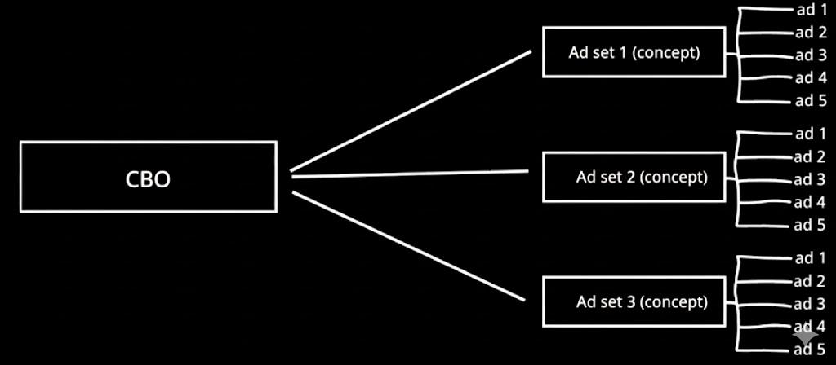

THE PIXEL TRUTH
Let me save you from a rabbit hole: the pixel is overrated.
The pixel is just a piece of JavaScript code that captures data and sends it to Facebook's servers. That's it. It doesn't "hold" data. It doesn't "learn." The ad account optimizes around the data on the server not on the pixel itself.
Don't worry about "seasoning" your pixel. Don't worry about "confusing" it by testing different products. Focus your energy on what actually matters: the ad account and the creatives.

SECTION 8: READING THE DATA DON'T BE EMOTIONAL
You've launched. Ads are running. Now what?
Full video on this here

MEASURE IN SPEND, NOT DAYS
Most people ask "how many days should I test?" Wrong question.
Measure in total ad spend, not time. You want at least $200–$300 in data before you make a real decision about whether something is working or not.
At $150/day, that's about 2 days. At $50/day, that's about 4-6 days. The spend is what matters, not the calendar.
That said, I like to run for at least 3 days because Facebook does have good days and bad days. But spend is the primary metric.

WHEN TO CUT
Simple rules:
Cut immediately if: An individual ad has spent past your breakeven CPA without a single sale. Dead. Kill it.
Cut if: An ad has dropped past your breakeven ROAS and is trending downward. Not going to magically recover. Kill it.
Don't cut if: You haven't spent enough to reach statistical significance yet. Give it the $200-$300 it needs.

50-70% OF YOUR CREATIVES WILL FAIL
Read that again. 50-70% of the creatives you test will not work. And that's totally okay. That's completely normal.
The game is not about having every ad work. The game is about finding the ones that DO work the ones that cracked the winning message and doubling down on them.
When something works:
- Create more variations of that concept
- Test it in different formats (image → video or vice versa)
- Scale the budget on that ad set
- Use that messaging on your landing page
When something doesn't work:
- Kill it
- Don't be emotional about it
- Move on to the next concept
Regardless of how hard you worked on something, you're just going to read the data as is.

SECTION 9: THE ROADMAP YOUR FIRST 30 DAYS
Damn bro… you really thought this shit takes 30 days to launch?
One product? 30 days? Cmon… Don’t you remember rule #4?
Money LOVES SPEED.

Day 1: RESEARCH + PRODUCT SELECTION
- Read this guide cover to cover (you're almost done)
- Validate product demand (SimilarWeb, GetHookd, Google Keywords)
- Check margins (both rules: $30+ gross margin AND 3x COGS)
- Identify your purple ocean positioning
- Select your product
- Run the Foundational Docs process for product

Day 2: STORE + CREATIVE PRODUCTION
- Set up Shopify store with Shrine theme
- Write all copy using Claude + foundational docs
- Create product images with NanaBanana Pro
- Create 1-2 product videos with Kling 3 or Sora 2
- Build out full product page
- Test your checkout flow end-to-end
- Set up Facebook Business Manager + ad account
  - IF THIS IS YOUR FIRST TIME IN AN ADS MANAGER… plz warm up your account for a few days… Basically you need to build trust with FB… run ads that will 100% get approved. Make consistent payments. Then you can start running your main ads.

Day 3: ADS + LAUNCH
- Create 9-18 ad creatives (3 concepts x 3-6 variations each)
- Mix of swipes (80%) and original concepts (20%)
- Set up 1 CBO with 3 ad sets
- Set minimum spend per ad set
- Launch with $50-$250/day budget

Days 4-7: OPTIMIZE + ITERATE
- Review data after $200-$300 in spend
- Cut losing ads (past breakeven CPA with no sale)
- Identify winning messaging concepts
- Create new variations of winning concepts
- Scale budget on profitable ad sets
- Repeat the cycle

DAILY HABITS FOR YOU TO START DOING…
- Check your data a few times per day. Not every hour. Once. In the morning.
  - Odds are you arents spending enough per hour for anything to be statistically significant
- Write in your learning journal. What worked? What didn't? What did you learn?
- Create at least 2 new ad creatives per day. Volume matters.
- Read your foundational docs. There's always a new angle hiding in there.
- Don't make emotional decisions. Sleep on it. Then decide.

SECTION 10: WHAT ARE YOU GOING TO DO ABOUT IT?
You just read the entire blueprint. The same framework I'd use if I were starting from absolute zero in 2026.
You know the mindset. You know the formula. You know how to find a product, build a funnel, create ads, read data, and scale.
The only question left is: are you going to actually do it?
Most people who read this guide will do nothing. They'll save it, bookmark it, maybe share it with a friend and never take action. That's fine. That's most people.
But if you're the kind of person who reads something and then DOES it then you've got everything you need to start.
And if you want to accelerate the process…
If you want direct mentorship, weekly calls, a community of people doing this alongside you, and someone who's been through every single mistake you're about to make…
Apply for Brand Builders Academy here
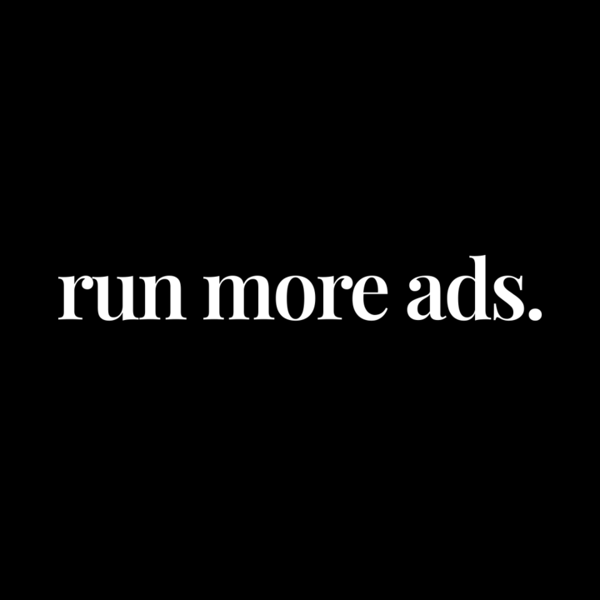
Now go build something.

